Chapter 1 - Earth in Space Lesson 1: The Sun-Moon-Earth System
Earth and the Universe
- Long ago, people thought the Earth was the center of the universe.
- Today we know that Earth is not the center of the universe.
- The Moon moves around, or orbits, Earth. Earth is one of eight planets that orbit the Sun. The Sun is one of billions of stars that make up the Milky Way galaxy. And the Milky Way is one of billions of galaxies in the universe.
Why do objects orbit the sun?
- Objects orbit the Sun because the Sun has more than 99 percent of the solar system’s mass. The Sun is the biggest object in the solar system and because of this the Sun has a huge gravitational pull.
- As the figure shows, the Sun’s diameter is 100 times greater than Earth’s diameter and 10 times greater than Jupiter’s.
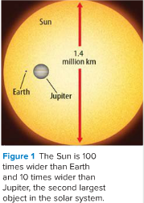
Motions of Earth
Earth’s Orbit
Earth is moving around the Sun because of the Sun’s huge gravitational pull. Without the Sun’s pull, Earth would move off into space in a straight line, as shown below.

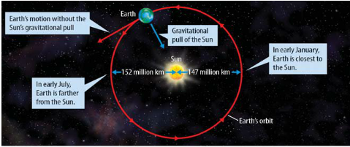

- Earth’s orbit is nearly round, or elliptical.
- The orbit of an object around another object is revolution.
- It takes Earth 365.25 days—one year—to revolve around the Sun once.
As shown above, the distance between Earth and the Sun is not always the same. An astronomical unit (AU) is the average distance between Earth and the Sun.
- One AU is nearly 150 million km. Scientists often use AUs to measure distances to planets and other objects within the solar system.

Earth’s Rotation
Imagine a rod pushed through the center of Earth from the North Pole to the South Pole.
The images of Earth in the figure at the below show this.
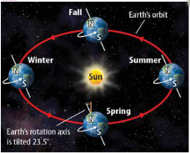
- The rod represents Earth’s axis.

- Earth spins, or rotates, on its axis like a top. Rotation is the spin of an object around its axis.

- Rotation is what causes day and night.

The side of Earth facing the Sun is in daylight, and the side of Earth facing away from the Sun is in darkness.
- Earth makes one full rotation every 24 h.

Earth’s Tilt and Seasons
- A common misconception is that the Earth’s seasons are due to the Earth’s changing distance from the Sun. This does not cause the seasons.
Look again at the figure below:
Earth is closest to the Sun in January, when it is winter in the northern hemisphere.
Seasons occur because Earth’s tilt does not change as Earth orbits the Sun, as shown in the figure below:
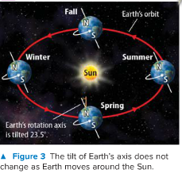

If you drew a line perpendicular to Earth’s orbital path, the angle of tilt between Earth’s axis and that line would be 23.5°.
As Earth moves, this angle of tilt stays the same. The North Pole and the South Pole always point in the same directions. But the position of Earth’s tilt as it relates to the Sun does change, as shown in the figure below.

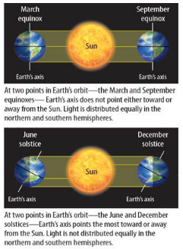

Spring and Fall
- An equinox occurs when Earth’s rotation axis is tilted neither toward nor away from the Sun.
- Equinox means “equal night.” - Hours of daylight equal hours of darkness during an equinox.
- An equinox occurs two days of the year, one in March and one in September.
- These days are used to signify the beginning of spring or fall, as shown below.
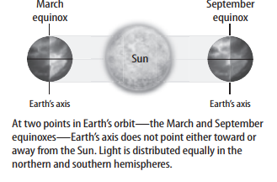
Summer and Winter
When Earth’s rotation axis is tilted directly toward or away from the Sun a solstice occurs.
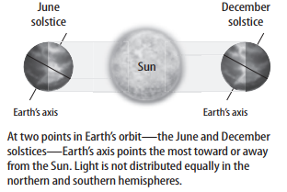
- Solstices happen in June and December.
- When the North Pole is toward the Sun, the northern hemisphere has summer. The northern hemisphere receives more direct sunlight, and there are more hours of sunlight during the day.
- At the same time the northern hemisphere is having summer, the South Pole is tilted away from the Sun, and it is winter in the southern hemisphere.
- The southern hemisphere receives less direct sunlight and there are fewer hours of sunlight.
- Six months later, the seasons are reversed.
Earth’s Moon
- The Moon is about one-fourth the size of Earth.
- The Moon is a dry, airless object made mostly of rock.
- Early in the Moon’s history, many asteroids and comets crashed into it, leaving huge craters on its surface.
- The Moon also has mountains and smooth, dark lava plains from ancient volcanoes.
- Gravity is the force that holds the moon in orbit around the Earth.
Formation of the Moon
Scientists propose that the Moon formed when a Mars-sized object collided with Earth soon after Earth formed. This collision threw debris into orbit around Earth. Gravity pulled the debris together, which formed the Moon.

Motions of the Moon
- The moon rotates on its axis, and it revolves around Earth.
- It orbits Earth once every 27.3 days. That is also how long it takes the Moon to rotate once.
Because one revolution of the Moon around Earth takes the same amount of time as one rotation of the Moon on its axis, the same side of the Moon always faces Earth, as shown in the figure.
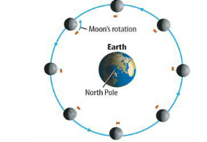
The side of the Moon that does not face Earth is called the far side. You cannot see it from Earth.
Phases of the Moon
The Moon does not create its own light. The Moon is visible only because it reflects sunlight.
As the Moon orbits Earth, the half of the Moon facing the Sun is in sunlight and the half facing away is in shadow, as shown in the figure below.

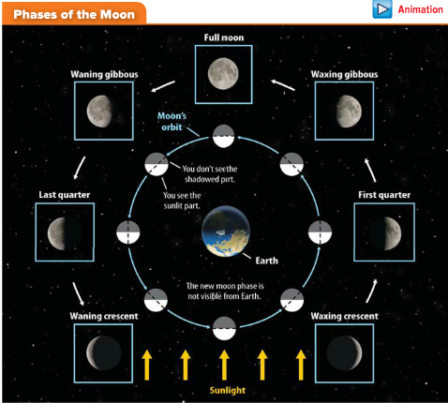

As the Moon orbits Earth, the part of the Moon that can be seen from Earth seems to change shape. These shapes are the phases of the Moon.
The Moon completes a cycle of phases every 29.5 days. Refer to the figure above as you read about each of the Moon’s phases.

New Moon and Waxing Phases
When the Moon is between Earth and the Sun, the sunlit half of the Moon faces away from Earth. The half facing Earth is dark because it is in shadow, as shown below. This phase is called a new moon.
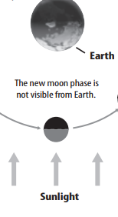
During the two weeks following a new moon, more of the Moon becomes visible. As the lit portion of the Moon becomes larger, the Moon is waxing.
The waxing phases are waxing crescent, first quarter, and waxing gibbous.

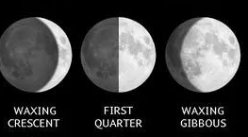

Full Moon and Waning Phases
When Earth is between the Moon and the Sun, the entire sunlit half of the Moon faces Earth. This phase is called a full moon.

During the two weeks following a full moon, less of the sunlit side of the Moon is visible.
As the lit portion of the Moon becomes smaller, the Moon is waning. The waning phases are waning gibbous, last quarter, and waning crescent.

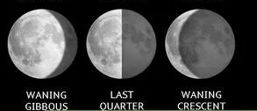

Tides
- Tides are the periodical rise and fall of the oceans’ surfaces caused by the gravitational force between Earth and the Moon and the Sun.
The Moon has about twice as much influence on tides as the Sun because it is so much closer to Earth.
Effect of the Moon
Locations on Earth closest to and farthest from the Moon have the greatest tidal effect.
As shown in the figure below, water on Earth bulges slightly at these locations. These are the places where high tides occur. In contrast, locations on Earth halfway between the two high-tide regions have low tides.

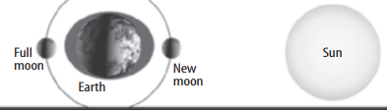

As Earth rotates, the locations of high and low tide change in predictable ways.
Most coastlines have two high tides and two low tides each day. But water depth, coastline shape, and weather also affect tides.
Effect of the Sun
When Earth and the Moon are in line with the Sun, the Sun’s gravitational pull adds to the Moon’s gravitational pull.
As a result, high tides are higher than usual. Tides at this time are called spring tides.
Spring tides occur during full moon and new moon phases as shown in the figure below.
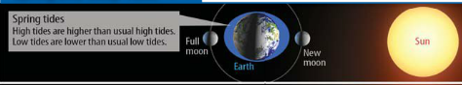

During the first and third quarter moons, the gravitational pull of the Moon is perpendicular to the gravitational pull of the Sun.
High tides are lower than usual. Tides at these times are called neap tides and are shown in the figure below.

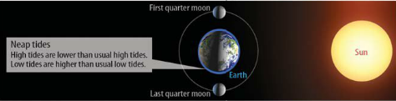

Eclipses
An eclipse is the movement of one solar system object into the shadow of another object.
You can view solar and lunar eclipses from Earth. As shown in the figure below, the type of eclipse depends on the positions of the Moon, Earth, and the Sun.

Solar Eclipse - A solar eclipse can only occur during a new moon. During a solar eclipse, a small part of Earth is in the Moon’s shadow. The Moon appears to completely or partially cover the Sun.
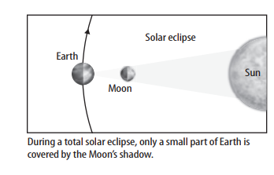
Lunar Eclipse - A lunar eclipse can occur only during a full moon. During a lunar eclipse, Earth’s shadow completely or partially covers the Moon. The Moon is visible during a total lunar eclipse. Light changes direction as it passes through Earth’s atmosphere. The light that reaches the Moon appears red.
